Yu Ma Testing Report

2015.11.2

**Test Report**

Test case 1:

To test the write speed, we need to initial a table and add values into it. First, in order to get the access to the database, we input the class for name, the URL of the database, the user name and the password. Then, we named our sample table as “test” and set the number of rows as 1000. The first column name was “id”. The value type was integer and the length was 9. And there was one data example needed. We input a 20. The second column name was “name”. The value type was varchar and the length was 30. We input “example” as data example. We set the primary key as “id”. Then one table with 1000 values was created by clicking the “Execute” button.

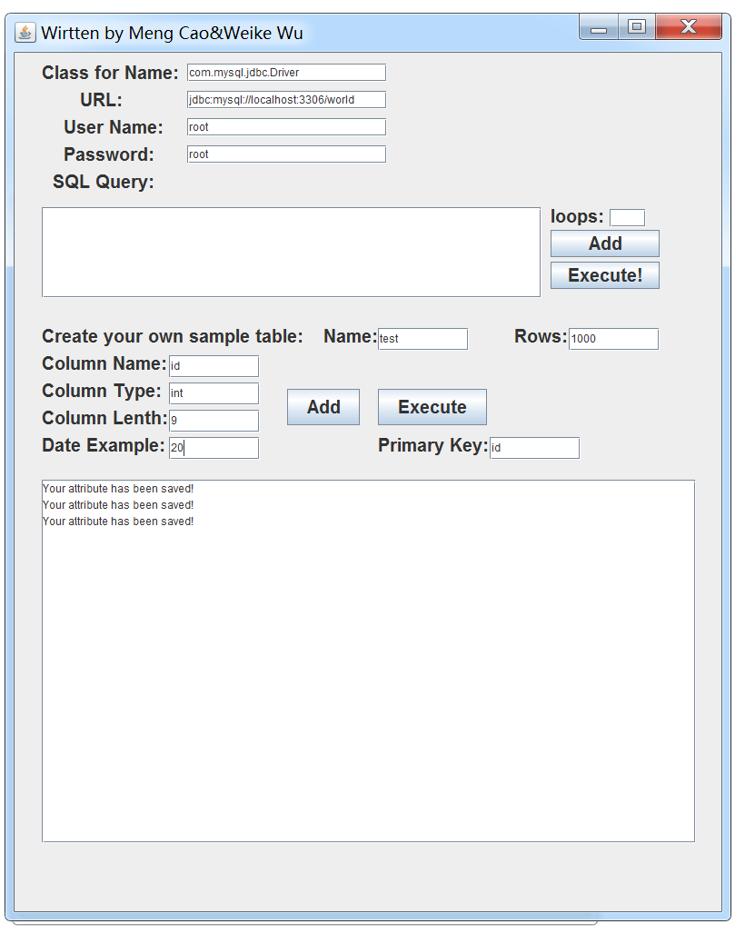

We can see in the Figure 1 that there were three tables in the system before we created the table ”test”. And now we had four, which means the table was created successfully. The write time of each value and the throughput are shown in the console. We got the results that we expected.

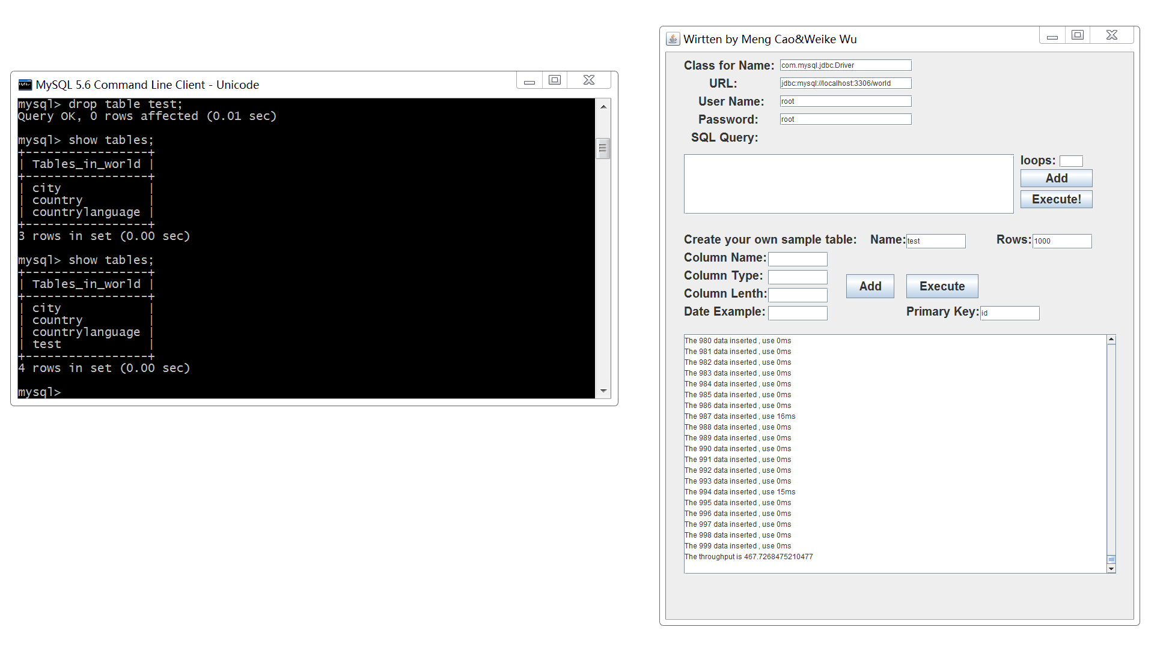

Figure 1

We used SQL command to show the data in table “test”, the results are below:

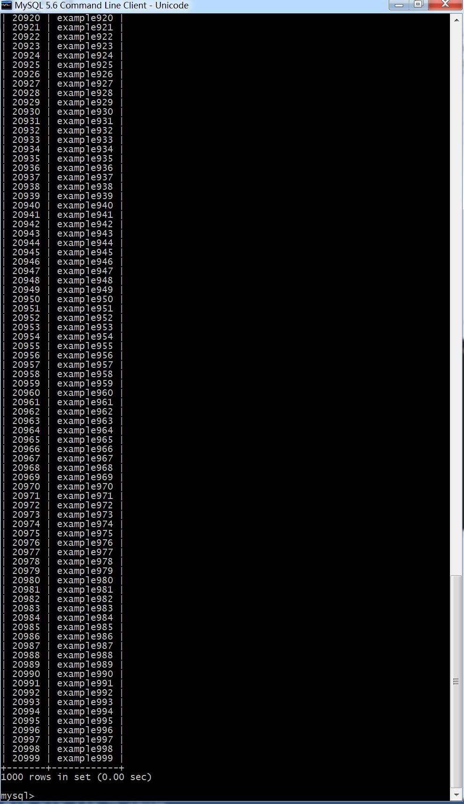

To test the read speed, we planed to multiply execute a SQL command to search a certain value in the table test and observed the time of each search. We decided to search 997, 998, 999 for 30 times. In the console, the time of each search is shown and we can also see the throughput clearly just as what we expected. The result is as Figure 2 shows:

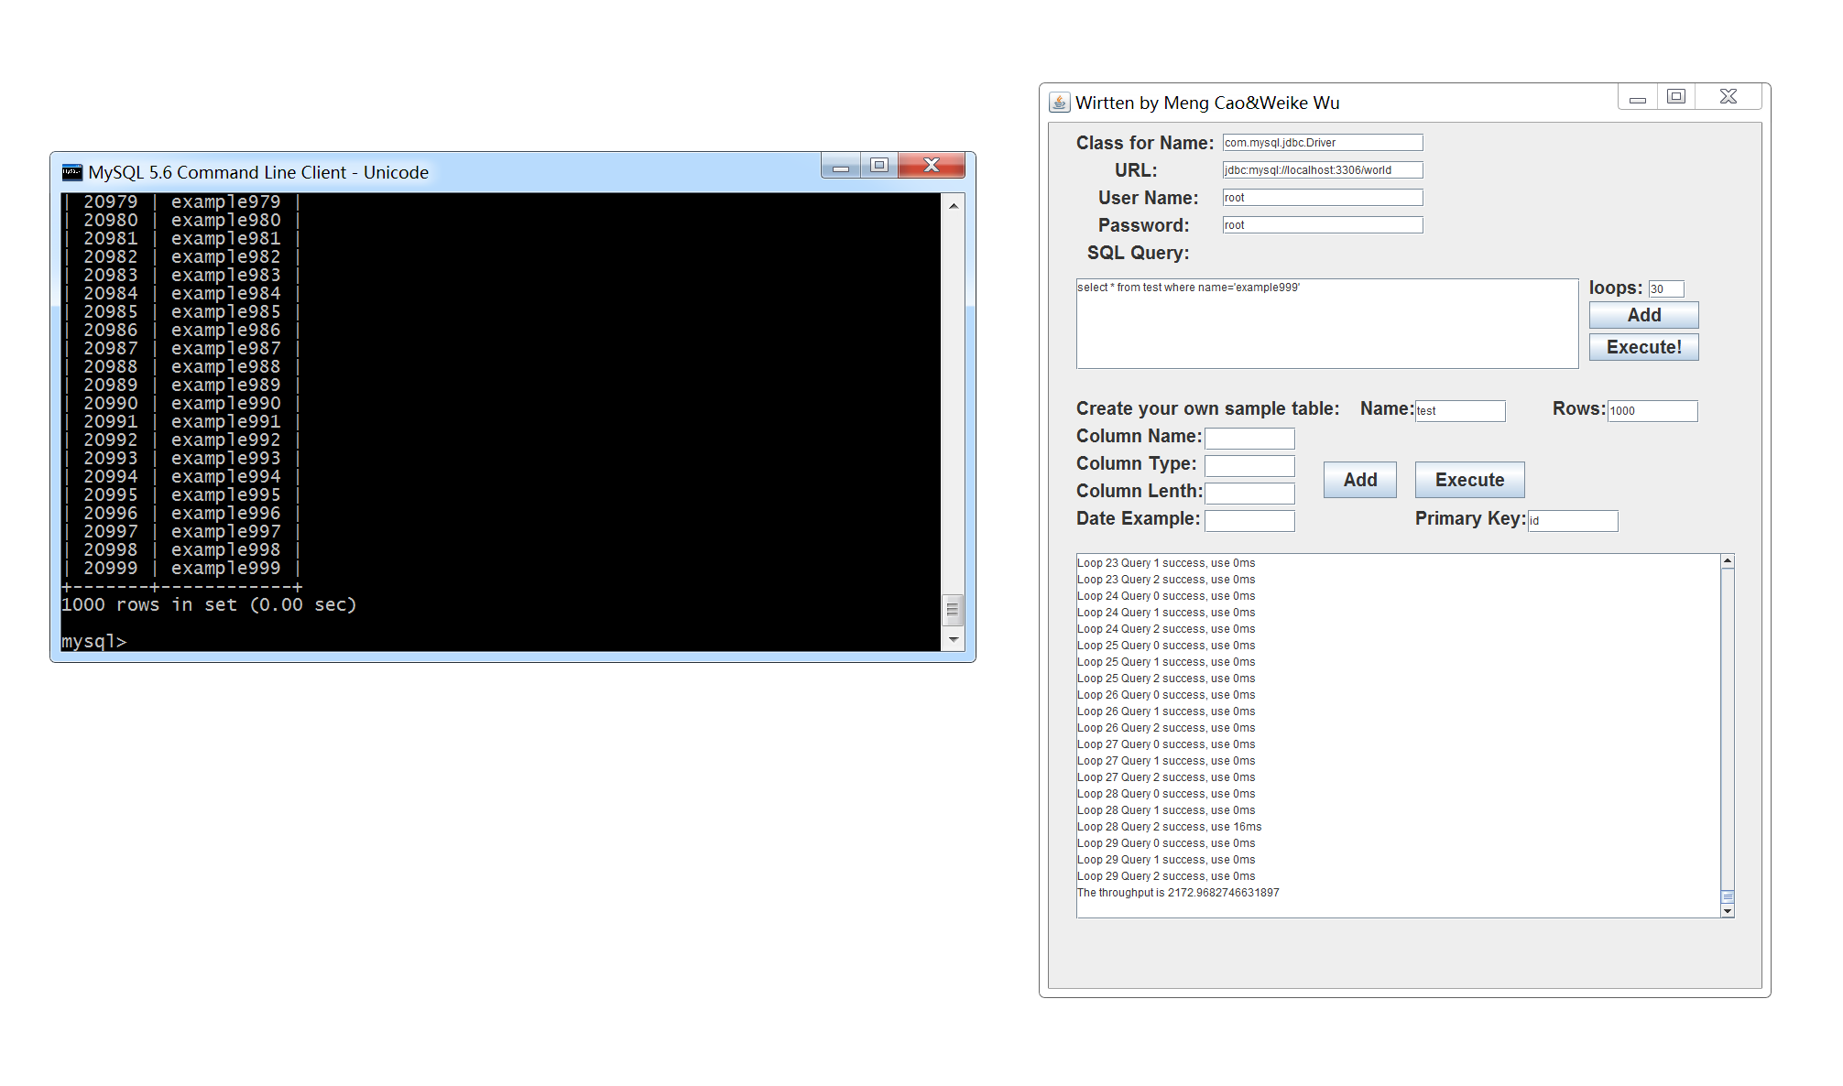

Result

The MySQL is a reliable database with fast speed of writing and reading. The read speed is approximately five times faster than write speed. And the test tool that team A developed successfully showed the accurate results as we expected. We recommend using this test tool.